1. What is the data-type usually used in arithmetic operation?

Answer: Usually using Int (Integer), but there are others data type that can be used for arithmetic such as Byte, Short, Long, Float, Double

1. What is the data-type usually used in word and character?

Answer: Character and String

1. 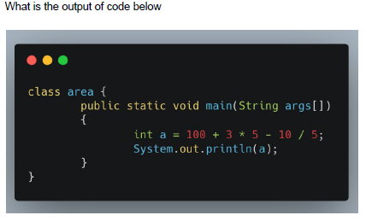

Answer: 113

1. 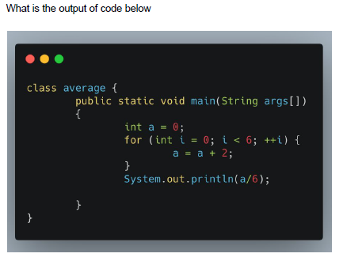

Answer: 2

1. 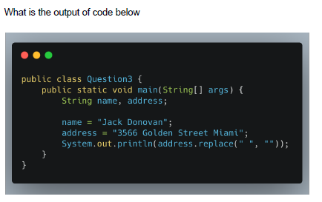

Answer: 3566GoldenStreetMiami

Flaky Test:

1. What is a flaky test?

Answer:  Is an analysis of [web application](https://searchsoftwarequality.techtarget.com/definition/Web-application-Web-app)  code that fails to produce the same result each time the same analysis is run. Whenever new [code](https://whatis.techtarget.com/definition/code) is written to develop or update computer [software](https://searchapparchitecture.techtarget.com/definition/software), a web page or an app, it needs to be tested throughout the development process to make sure the application does what it’s supposed to do when it’s released for use. Logically, when put through the same test over and over, the code will produce the same result -- the application will either work properly every time, thus passing the test, or fail to work properly every time, thus failing the test.

Flaky tests can be caused by various factors:

* an issue with the newly-written code
* an issue with the test itself
* some external factor compromising the test results

1. An element in a website is using ajax/javascript to show the data (processed as asynchronous). What do you do to test that element?
   1. The JavaScript object XMLHttpRequest lets you send HTTP requests.
   2. Its open method lets you configure the request.
   3. Its send method sends the request to the desired URL.
2. A website page can only be accessed with CAPTCHA. How do you test that page?

Answer:

1. Either ask dev team for a workaround, like configure CAPTCHA in test environment in such a way it will always accept 1 specific value.
2. Ask developer to disable the CAPTCHA module in testing environment.
3. If your are using custom CAPTCHA module, you can ask developer to generate an API of CAPTCHA generation for testing environment.
4. You can ask dev team to add CAPTCHA code as title in markup, then you can access this title and bypass the CAPTCHA, but only in the testing environment.

Essay Question Topic

1. 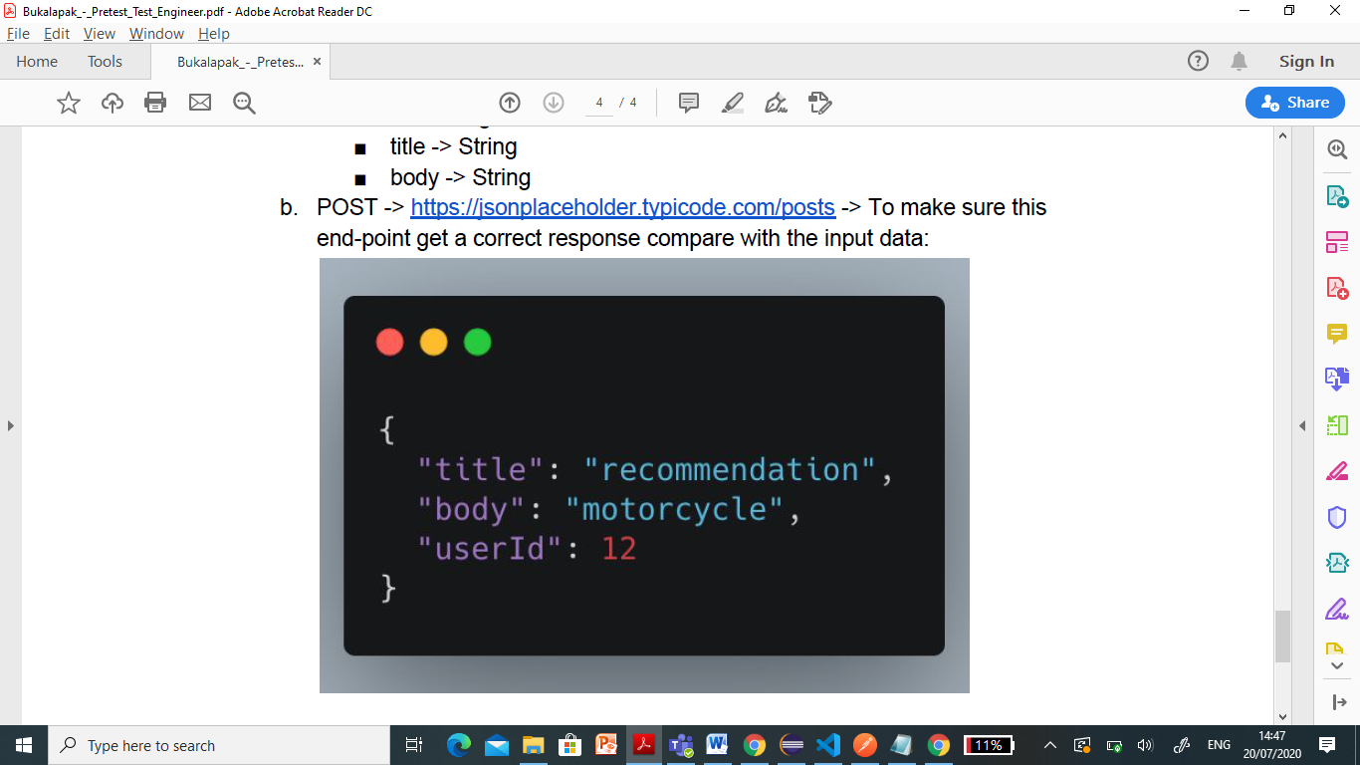

**package** co.progress.selenium.demo;

**import** org.junit.Test;

**import** io.restassured.RestAssured;

**import** io.restassured.response.Response;

**public** **class** GetRequestAutomation {

@Test

// public static void main(String[] args) throws IOException, ParseException {

**public** **void** getRequestAutomation() {

RestAssured.*baseURI* = "https://jsonplaceholder.typicode.com/posts";

Response respon = RestAssured.*given*().param("userId", "12").when().get();

System.***out***.println("Respon: " + respon.asString());

}

}

1. Create automation test script to test 1 of these scenarios using Bukalapak website:

a. Register

b. Login

c. Add to Cart

d. Search Product

Answer: (Script for search product)

**package** co.progress.selenium.demo;

**import** org.openqa.selenium.By;

**import** org.openqa.selenium.WebDriver;

**import** org.openqa.selenium.chrome.ChromeDriver;

**public** **class** TestBukalapakRegister {

/**

* **@param** args

* **@throws** InterruptedException

*/

**public** **static** **void** main(String[] args) **throws** InterruptedException {

System.*setProperty*("webdriver.chrome.driver", "C:\\Belajar Selenium\\chromedriver_win32\\chromedriver.exe");

WebDriver driver = **new** ChromeDriver();

driver.get("http://bukalapak.com");

driver.manage().window().maximize();

Thread.*sleep*(1000);

driver.findElement(By.*id*("v-omnisearch__input")).sendKeys("Earphone");

Thread.*sleep*(1000);

driver.findElement(By.*xpath*("//button[@class='v-omnisearch__submit']//*[local-name()='svg']")).click();

Thread.*sleep*(1000);

}

}